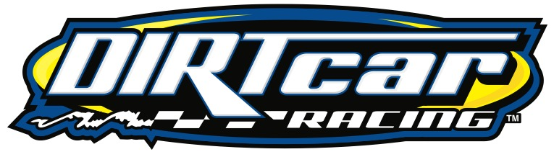

DIRTcar Sanctioning Value for you and the racers!

Competitors:
- A $50,000 excess medical coverage that comes with the DIRTcar Membership at DIRTcar sanctioned events. Coverage available for driver, car owner and crew members
- Chance to earn points for the Hoosier Tire Weekly Points. Top-16 finishes from each competitor are counted towards the points. Points are earned from opening night through Labor Day Weekend
- Chance to earn home track bonus points for overall Championships in DIRTcar 358 and DIRTcar Sportsman
- Uniform rules when traveling to Series events and DIRTcar Sanctioned Tracks
- Pit Pass savings at applicable tracks
- Right to appeals process
Tracks:
- Listing in the weekly Hoosier Racing Tire Newsletter - https://dirtcar.com/uncategorized/hoosier-weekly-racing-update-may-23-2022/
  - Hoosier Racing Tire Newsletter distribution to several thousand fans and competitors via email, social and website
- Track listing in our master DIRTcar Schedule which includes ALL your race dates with link to your website - https://dirtcar.com/schedule/
- Ability to reach out to any DIRTcar Technical Staff
- Super DIRT Week ticket package that includes pit passes, parking, and camping
- Display and Promotional opportunity at Super DIRT Week
- Year-long promotional opportunity using up to six (6) week-long Super DIRT Week tickets
- Tracks receive $30 for every membership sold
- Discounted DIRTcar Uniforms for officials which can be branded with track’s logo (One provided)
- DIRTcar Feature win decals
- Promoter Hard Card grants admission to any other DIRTcar sanctioned track as well as DIRTcar Nationals in Volusia and World Finals in Charlotte
- Email blast availability to all members to promote special events
- If you hold a Series event, free advertising collateral provided
- Discounted yearly schedule cards and posters provided
- Availability to advertise events on DIRTVision
- Advertising opportunity, both video and static, on videoboards used at Super DIRTcar Series events
- Added PR & Promotion support on your sanctioned division(s)
- Strong relationships with our partners Hoosier Racing Tires and VP Racing Fuels

